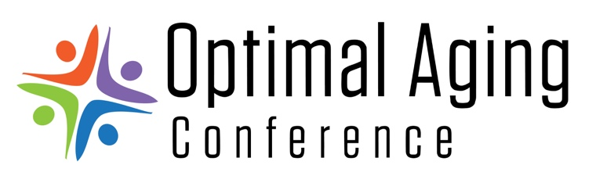

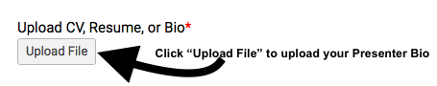
Presenter Bio Template
If you do not have a CV or a resume to submit with your presentation proposal, please use the below Presenter Bio Template. Please save this document as “LastNameBio” and upload in the presentation proposal submission form.

If you have any questions in how to complete or upload your bio to your presentation proposal form, please call us at 502-852-5629.

Presenter Name:
Current City & State of Residence:
Current Job Title or Role in Community:
Credential, Degree/education, as applicable:
Please provide a 100 word paragraph describing your work, volunteer, and other personal/community experience related to the topic of aging:

