HOW IT WORKS 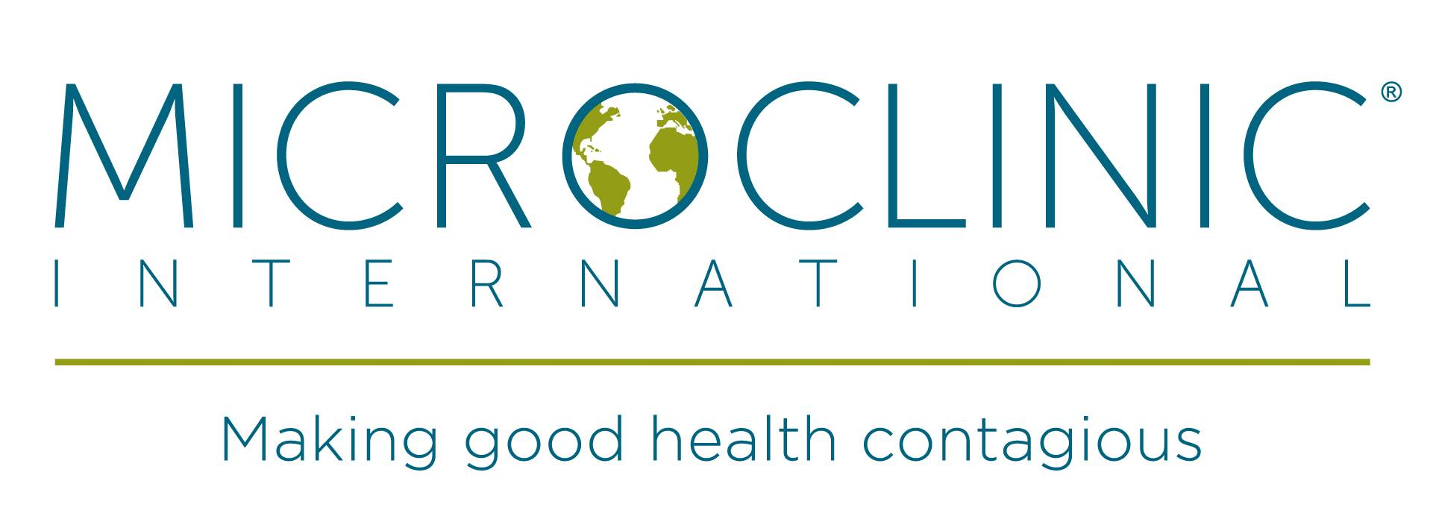
http://microclinics.org/
The Microclinic Model Team is a unique approach to community health and wellness.

A ‘microclinic’ is not a small building, but a human infrastructure - a health management collective composed of people who share access to education, technology and social support as members work together to prevent and manage deadly disease. Microclinics are formed organically from extended families, small businesses, church groups, and more. Rather than attempting to create a new social support system, microclinics galvanize existing social networks. Built on relationships and social capital rather than bricks and mortar, microclinics put the power of health directly into the hands of the community.

Anatomy of Microclinic Program:
Addressing Social Networks to Address Chronic Disease

- Small teams of two - six family members, friends and colleagues form a microclinic. They set incremental goals to improve their health and support each other in reaching those goals.
- Multiple microclinics (groups) come together to learn how to make sustainable changes to prevent or manage diseases in a fun environment. Healthy lifestyle changes are the goal for all involved. Most need to lose weight, but not all.
- Leaders/facilitators can be health educators, teachers, community health workers, nurses, but we encourage community members who have taken the class. Every day people who can model life style changes are valuable resources and paired up with veteran leaders.
- We see better health for individuals who spread that to their families and communities, the ultimate believe that health is contagious.
- 95% of participants who completed a Microclinic Program improved in at least one clinical indicator (weight, body mass index, blood pressure, cholesterol and blood sugar.)
- Participants influence their social network, spreading health behaviors to friends, family, co-workers, and neighbors.
- During and after the program, participants spread healthy habits to their communities, often joining local efforts to improve community health that include building community gardens and expanding access to healthy food options.

Who we are:
Microclinic International (“MCI” which was originally incorporated as “Global Micro-Clinic Project”) is a not-for-profit development organization that seeks to revolutionize how deadly diseases are prevented and managed worldwide. The organization was founded by Daniel Zoughbie in 2005 in honor of his Grandmother who died of diabetes in Palestine.

Building on epidemiological evidence suggesting that healthy behaviors are transmittable across social networks, the Microclinic Social Network Model leverages human relationships to address both non-infectious and infectious disease epidemics such as diabetes and HIV/AIDS. If negative behaviors like smoking, unsafe sex, and overeating can be contagious, so can positive, healthy behaviors. This is what we call “contagious health.” To date, we have established and evaluated over 1,500 Microclinics across four continents.

What we do:
A “Microclinic” is not a small building, but a human network consisting of small groups of people who share access to education, technology, and social support as members work together to prevent and manage a deadly disease. Built on social relationships and social capital rather than bricks and mortar, Microclinics put the power of health directly into the hands of the people who need it most.

MCI works with local partners to address a widespread and debilitating disease in the affected community. Through a series of community-based workshops with trained facilitators, each Microclinic is equipped with practical skills and a system of reliable support needed to transform the social and economic determinants of these deadly diseases in their own networks of family and friends. Throughout the training process, Microclinics create a robust information dissemination system that can be readily tapped by local and international organizations to effectively coordinate successive trainings and build local capacity. Far from a vertical intervention for a single disease, the Microclinic Model facilitates a broad community-level transformation by reinforcing the social infrastructure so that it is able to support an expanding range of health, education, agriculture, microfinance, and livelihood programs within marginalized populations.

Why we are unique:
In addition to offering an innovative social network-driven method of addressing debilitating diseases, MCI is committed to rigorously evaluating our projects with the aim of enhancing their effectiveness and success. Using sophisticated cohort studies and randomized controlled trials, MCI has demonstrated the effectiveness of the Microclinic Model through statistically significant improvements in the health indicators of our program participants. Upon achieving evidence-based success, MCI seeks to affect policy-making in the communities in which we work in order to expand and institutionalize our programs. MCI’s three-fold approach of 1) program launch and management, 2) research and evaluation, and 3) policy and advocacy has allowed us to catapult community-based Microclinic Programs into effective regional public health policies. Our experience has demonstrated that health is indeed contagious—across social networks, communities, and nations.

Publications:

Evaluation of Healthy2Go, a country store transformation project to improve the food environment and consumer choices in Appalachian Kentucky

Results of the RCT in Bell County, Kentucky with 16‐month follow up published in the American Heart Association Journal Circulation

Results of the RCT in Bell County, Kentucky published in the American Heart Association Journal Circulation

Research:

http://circ.ahajournals.org/content/128/24/2704.full

http://circ.ahajournals.org/cgi/content/meeting_abstract/127/12_MeetingAbstracts/A009

http://download.thelancet.com/flatcontentassets/pdfs/CUGH--‐
2014/CUGH_abstracts_p3_50_Part17.pdf

